

OBJECT DETECTION SYSTEM

Using computer vision technique



JULY 12, 2023

By vairavan

What is computer vision?

Computer vision is a field of artificial intelligence (AI) that enables computers and systems to derive meaningful information from digital images, videos and other visual inputs and take actions or make recommendations based on that information.

Computer Vision Applications:

* Facial recognition.
* Self-driving cars.
* Robotic automation.
* Medical anomaly detection.
* Sports performance analysis.
* Manufacturing fault detection.
* Agricultural monitoring.
* Plant species classification.

1).Facial recognition:

Facial recognition is a way of identifying or confirming an individual’s identity using their face. Facial recognition systems can be used to identify people in photos, videos, or in real-time.

# 2). Self-driving cars

Self-driving cars use computer vision to detect objects. Object detection, in turn, takes two steps: image classification and image localization. Image classification is done by training the convolutional neural network (CNN) to recognize and classify objects.

## 3). Robotic automation

Computer vision enables robots to perceive and understand their surroundings, creating detailed maps and effectively planning their movements. This capability is invaluable in warehouse automation, autonomous vehicles, and search and rescue missions.

Common Tools for Computer Vision:

1. OpenCV – Real-Time Computer Vision Library.

1. Viso Suite – No-Code Computer Vision Platform.

1. TensorFlow – Software Library for Machine Learning.

1. CUDA – Parallel Computing and Programming.

1. MATLAB – Programming Platform for Engineers and Scientists

1. Keras – The Python Deep Learning API



Develop an object detection system using computer vision techniques. Choose a specific object category (e.g., cars, pedestrians) and use a labeled dataset to train your model. Evaluate the model's performance in terms of detection accuracy, precision, recall, and provide insights into potential applications of the system.



Step1:

## Import all the needed modules

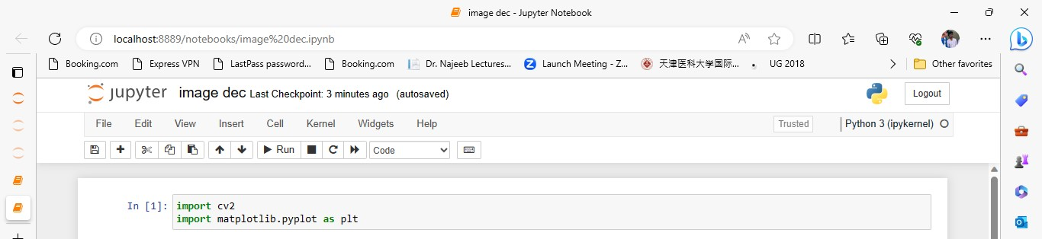

Step2:

## Create a dataset as a text file

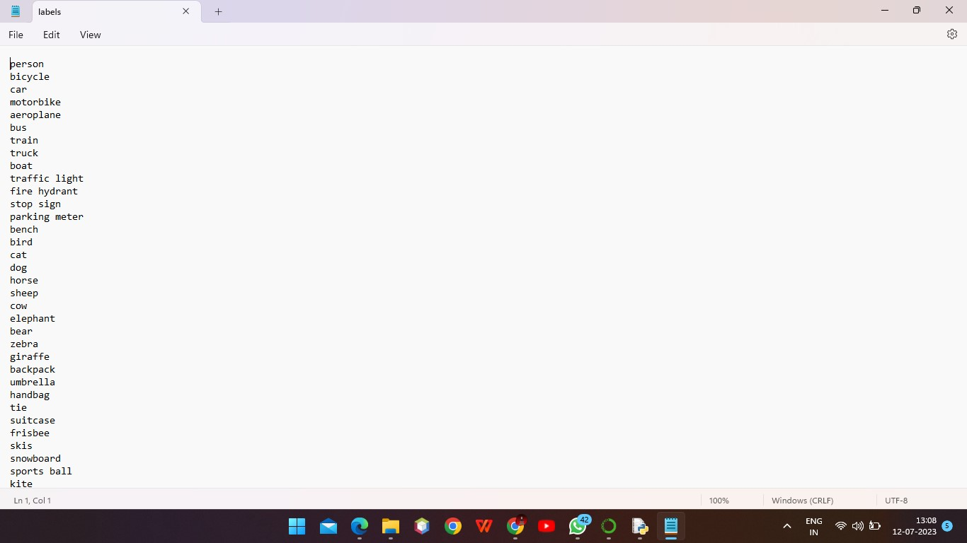

Step3:

## Add the model file to the program



Step 4:



Step 5:

## Print the labels

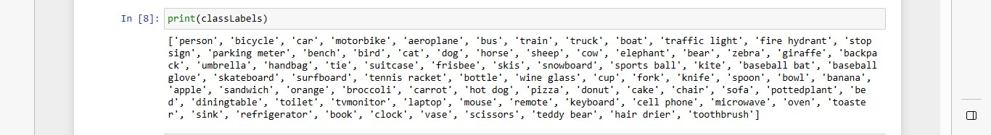

Step 6:

## Get the img and display it

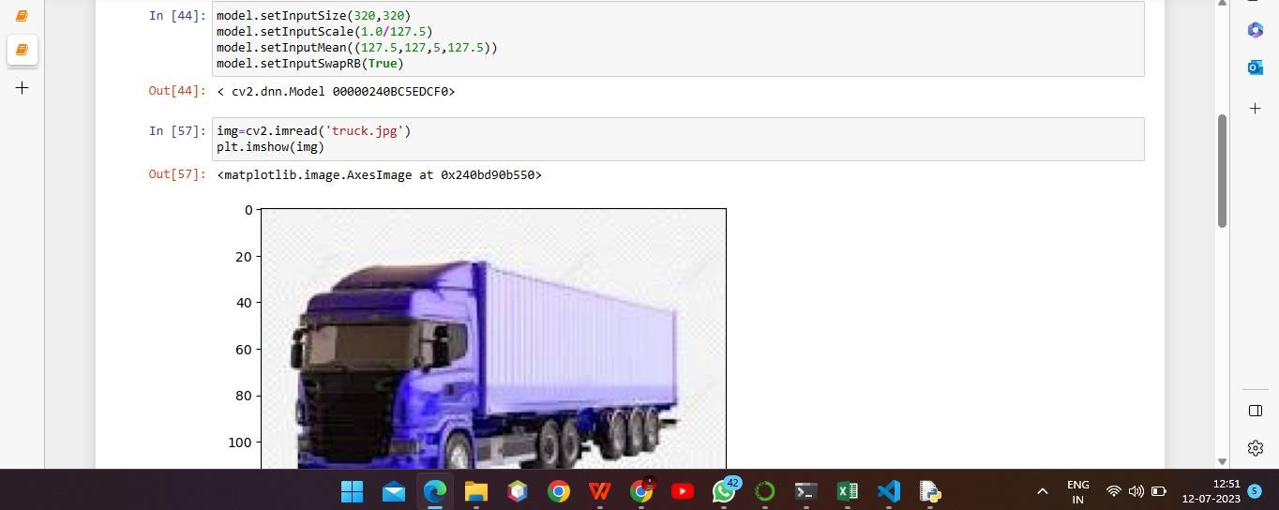

Step 7:

## Main part for the detection

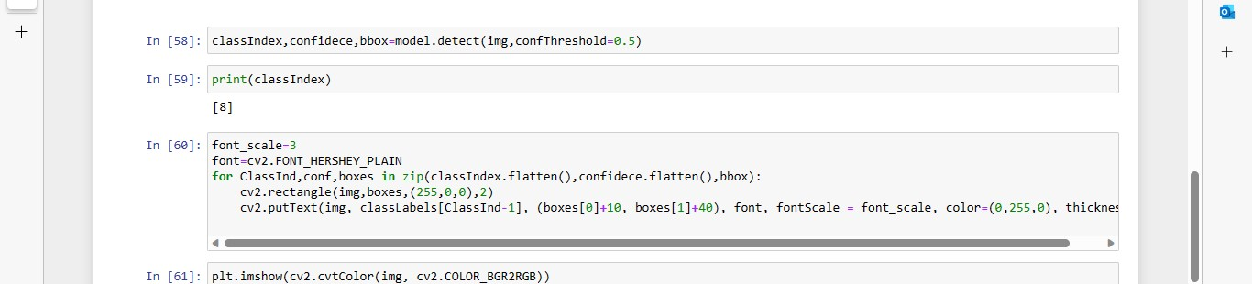

Step 8:

## Final output

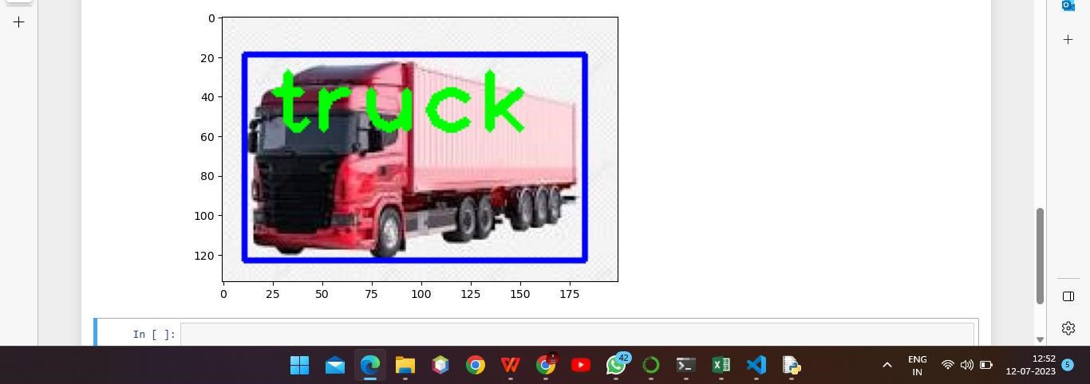

Thank you!!